**20th Birthday Of Cartoon Network**

There are lot's of memory which can take you to another dimension. Those memories make you feel well. I think the proper word will be 'nostalgia'.Yes, Cartoon Network make me feel nostalgia. Because of their shows which made my childhood full of happiness and also others. I am talking about 90's kid. They had a great childhood just because of [Cartoon Network](https://www.cartoonnetworkindia.com/).

[](https://4.bp.blogspot.com/-S1c-A39L1NM/W7IVL_I-b2I/AAAAAAAAAFQ/fCsS8QIMMecJ4gf-LrpPAlMt99Nb_I8hgCLcBGAs/s1600/2000px-Cartoon_Network_2010_logo.svg.png)

Today October 1,

Birthday of Cartoon network. **Happy 20th Birthday Cartoon Network**. I will name some of the cartoons which made my childhood special.

**Tom And Jerry**

[](https://3.bp.blogspot.com/-x45j-B_T7wg/W7IVbQc_Y0I/AAAAAAAAAFU/lKaHQg3cfHUpj5U2zjM4kB6rKKJQVSnZwCLcBGAs/s1600/KQpNPBA__400x400.png)

Everybody has seen this cartoon. It's also a favourite of everyone. When I was little I could watch Tom and Jerry all day long. These were glory days of my childhood life. When there was too much happiness just for a cartoon. And the secret is I still watch Tom And Jerry whenever I get time.

**Ben 10**

[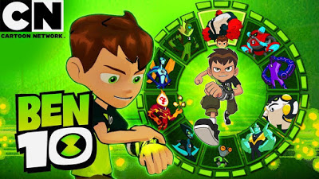](https://3.bp.blogspot.com/-1ebyIgZI4SM/W7IVpdq4pHI/AAAAAAAAAFc/lTkDdqGAsI8zAz8r6Ced5EFfE3lIOwMxACLcBGAs/s1600/maxresdefault%2B%25281%2529.jpg)

When I grew little older I started [Ben 10](https://en.wikipedia.org/wiki/Ben_10) series. It was so much good. I would pass hours and hours imagining one day I would get an Omnitrix of my own. And I also can be like Ben. I still remember my cousin also used to think like that. But we never got Omnitrix which can turn us into some kind of alien. So, Ben 10 was also one of my favourites.

**Dragon Ball Z**

[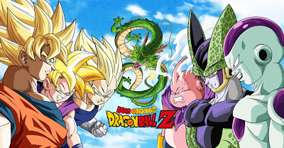](https://3.bp.blogspot.com/-DE1NoTOUGjI/W7IV07b5uaI/AAAAAAAAAFg/hlBakX1y944zjfpp3fNT4vmO28tK40J6gCLcBGAs/s1600/originals-fw18-dragonball-mh-d-v1_tcm66-283071.jpg)

This is one the best thing ever happened to me. [Dragon Ball Z](https://en.wikipedia.org/wiki/Dragon_Ball_Z) was damn a series. When I was 10 or 11 maybe, one of my cousins suggested watching Dragon Ball Z, and bingo. I did the right thing. I started this series and never missed an episode of it. It was too much pleasure watching Goku transforming into super syan, [Gohan](https://en.wikipedia.org/wiki/Gohan) and [Vegeta](https://en.wikipedia.org/wiki/Vegeta) doing fusion and transforming into new form Gojeta.

These were my favourites. There were more. I think you should also think about which was your favourite from cartoon network. This memory will make you feel good.

**Happy 20th Birthday Cartoon Network**. Thank you for everything and making my childhood special.